SUPPLEMENTARY MATERIALS

A Dolphin Peripheral Blood Leukocyte cDNA Microarray for Studies of Immune Function and Stress Reactions.

Annalaura Mancia, Mats L. Lundqvist, Tracy A. Romano, Margie M. Peden-Adams, Patricia A. Fair, Mark S. Kindy, Blake C. Ellis, Sebastiano Gattoni-Celli, David J. McKillen, Harold F. Trent, Yian Ann Chen, Jonas S. Almeida, Paul S. Gross, Robert W. Chapman, Gregory W. Warr.

Figure S1
Figure S2
Figure S3

Legends to Figures S1, S2, S3

Table S1
Table S2

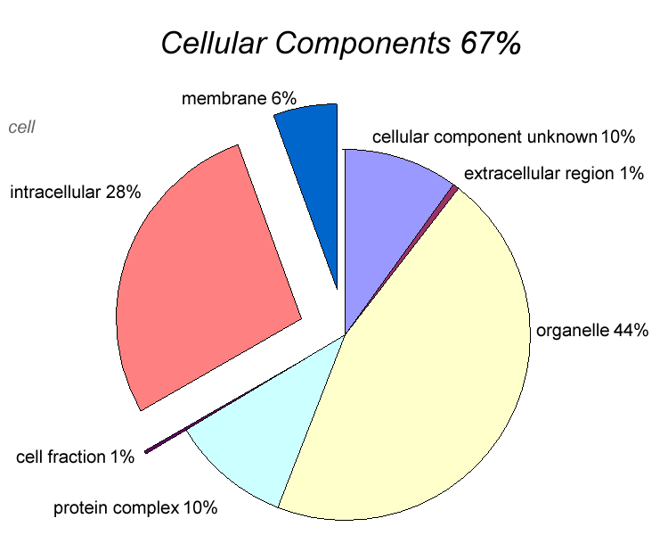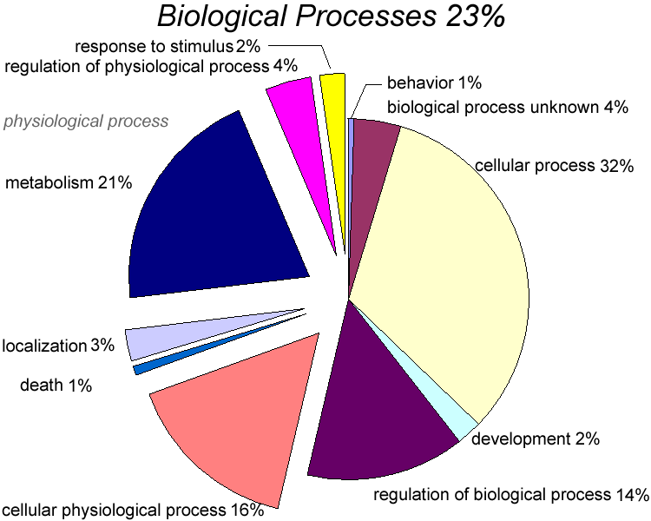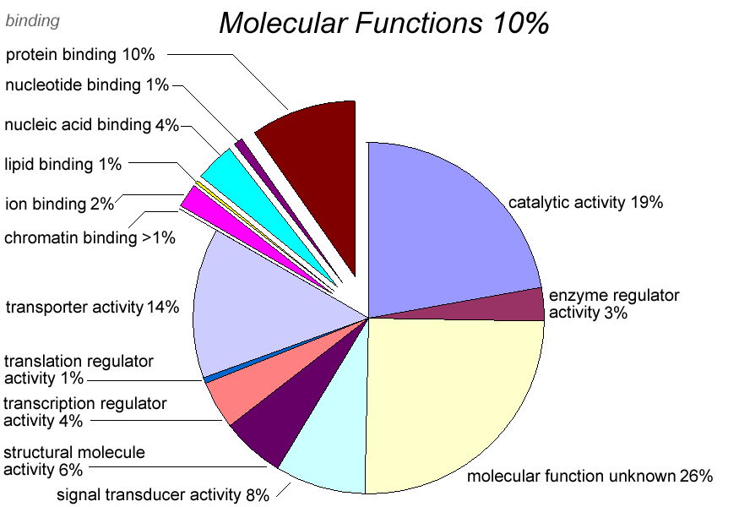

Fig.S1

Figure S1. GO Annotations of Dolphin Unigenes.
The 1343 unigenes collected from the PBL libraries were categorized in terms of overall gene ontology (left) and first-order subgroups (right). The full hierarchical analysis of dolphin unigenes can be found at www.marinegenomics.org. The GO annotation shown here was created with GOCART (Gene Ontology Contig Annotation Recovery Tool).

Fig.S2a

Fig.S2b

Figure S2. Hybridization of Dolphin PBL RNA to the Microarray.
a) Scatter plot of raw intensity values from 3 replicate arrays performed with wild dolphin PBL RNA. b) Scatter plot of the rank order normalized (quantile) intensity data from the 3 replicate arrays

Fig.S3a

Fig.S3b

Figure S3. Assigning significance to differential gene expression.
(a) Density distribution ”heat map” derived from the scatter plot shown in Fig S2b, and (b) conditional cumulative probability distribution (as a contour map) for differential gene expression, (observed vs. expected) derived from the heat map shown in (a).

Table S1. Targeted stress and immune function genes of the dolphin cloned by RT-PCR.
Gene | Forward primer / Reverse primer ª | Amplicon (bp) | Acc.no.
Receptors
TLR-1 | TGA TGC CCT GCC TAT ATG CAA AGA /  TTC ACR TTT GAA ATT GAG AAA TA | 469 | DV799564
TLR-2 | CAR CAT TTA AAA TCA TTA GAA T /  CTT ATT TCT GGA AAT ATA RAG | 395 | DV799561
TLR-3 | TAA GCA ACA ACA ACA TAG CCA ACA /  CAA AAT TTG AGA GAT TGG TCT T | 822 | DV799560
TLR-4 | CTC TGC CTT CAC TAC AGR GAC TT /  TRA GTC TTC TCC AGA AGA | 321 | DV799558
TLR-5 | AGA ATG CTT TGC TCA AAC ACC T /  AGA AAC CAG CCA ACA TCC TGG A | 363 | DV799591
TLR-6 | ACA ACT GAA TTT CTT GGG AT /  ACA GGT TTG GGC CAA AG | 395 | DV799545
TLR-7 | ATG TGA TCG TGG ACT GCA CA /  CAA GGA TTT CGA TAA TAA CAG T | 429 | DV799543
TLR-8 | AGA ACT TAG TCT AAT TCA AAA /  GAA GTG CTA GAG AGG TTT AG | 446 | DV799544
MHC-I | TGT TCT GGT AYC RTC AGT TCC CRR AAC /  CAR ARG TAG AGG CTG CTG TC | 64 | DV799539
MHCIIα | GTG GAC AAC ATC TTT CCT CCT GT /  CAG TGC CCA CCA CGA TGC CCA | 305 | DV799553
MHCIIβ | ATC CTT TTA CAA CCR TTC CTG G /  TGC ATC AAG AAG ACC CAA GA | 270 | DV799547
CD79A | TAT GAC CAT GAT TAC GCC AAG C /  TAG AGG CAG YGA KTA AGG GCT G | 670 | DY470720
CCR | ATC TCC AAC GTC AGC CAG CTC /  ATA TTT TCC TTA CAA AAC CT | 143 | DV799556
IL-8R | GTT GCC TGG TCT TCC TGG CTG /  AAA CTC ACT CAT GGC TTT GTA G | 392 | DV799562
TCR-α | GCC GTG TAC CAG CTG ARA /  GTT TCA AAG CTT TTC AC | 310 | DV799549
TCR-β | TGT TCT GGT AYC RTC AGT TCC CRR AAC /  CAR ARG TAG AGG CTG CTG TC | 184 | DV799587
TCR-β | TCT GAA TTC TCG AGT CGA CAT C /  AGG GCC TCG TGC TGA TGG CCA | ~600 | DV799580
TCR-γ | ACT GGT ACC GGC ARA AA /  CCA GCC RGC ACA GTA GTA | 194 | DV799586
TCR-δ | CTC TCC AGK CTG CTC TGG GTG /  GCA CAG AAG TAC TTT GCA GA | 221 | DV799579
TCR-δ | TCT GAA TTC TCG AGT CGA CAT C /  AGC AGC TTC CCA GTG GAG AGA | ~300 | DV799585
Signal Transduction
IκK-α | AGG AGA AGT TCG GTT TAG TAG /  TAA ACC ATA TAG CTA TCA CAG CC | 407 | DV799572
IκKβ | ATG TGG GGC CTG GGA AAT GAA /  GCC ARG GTG CCG AAG CTC CAG TAG | 602 | DV799570
NFκB | ATA CCT TCA AAT ATT AGA GCA A /  TCC ATC TCC TTG GTC TGC TGC A | 498 | DV799552
STAT-1 | AGA CTG TTG GTG AAA TTG CAA /  CAC CAG CAT GTT GTA CCA | 487 | DV799551
STAT-4 | ATT CTT CCC CTY TGG ATT GAT GGG T /  AAG GCT TTG TCT TTG GGA ATG TCA | 320 | DV799565
STAT-6 | ATC CTT TTA CAA CCR TTC CTG G /  TGC ATC AAG AAG ACC CAA GA | 603 | DV799550
PKC | TCT TCA AGC AGC CCA CCT TCT GCA /  CAG GTG TCA CAT TTC ATC CCC T | 277 | DV799563
Pro-inflammatory Cytokines
LT-α | ACC CCA GCA AGC AGA ACT CAC T /  GTG TGG GTG GAY AGC TGG TCT C | 385 | DV799542
TNF-α | ATG AGC ACT GAA AGC ATG ATC C /  ATG GCA GAG AGG AGG TTG ACC TT | 702 | DV799582
IL-1α | AAA GTC CCC GAC CTC TTT GAA GA /  CAG CTA TGT CAA ATT CCA CTG CC | 798 | DV799590
IL-1β | TAC CTG AAC CCA CCA ACG AA /  ATC GCC TTT CAT CAC ACA AGA C | 801 | DV799584
IL-6 | ATG ATA CCA CTT CAG ACA GAC /  ATC TGC ACA GCC TCG ATG C | 286 | DV799581
IL-12 | AGG AAG ATG GAA TTT GGT CCA /  ATG AAG AAG CTG CTG GTG TAG TTT T | 369 | DV799576
IL-16 | ACT GAC TCY GCA GCC TCA GC /  GTG ACA GGT CCA TCA GGC A | 311 | DV799567
IL-17 | CTG CTG CTG AGC CTG GMG GC /  CAG GAC CAG GAT CTC TTG CTG GAT | 338 | DV799566
GM-CSF | ATG CCA TCA AGG AGG CCC TGA /  AGC GAT CTG TGA GGT AAG CTT | 377 | DV799573
RANTES | GGC CGC CCT CTG CGC TCC /  TTC TTY CTG GTG ATA AAG AC | 165 | DV799578
RANTES | TCT GAA TTC TCG AGT CGA CAT C /  TGC ATC TGC CTC CCC ATA TGC | ~700 | DV799574
Th1-cytokines
IL-2 | AGT CAT TGC TGC AGG ATT TAC /  ATC ATC ATA TTC ACA TGT GAA TC | 321 | DV799577
IFN-γ | ACC AGT TAT TTC TTA GCT TTT CAG C /  TCT CTG GCC TCG AAA CAG ATT | 501 | DV799583
Th2-cytokines
IL-4 | TGC TAG TCT GCT TAC TGG CAT GTA /  TGG CTT CAT TCA CAG AAC AGG T | 303 | DV799593
IL-10 | GTT GCC TGG TCT TCC TGG CTG /  AAA CTC ACT CAT GGC TTT GTA G | 460 | DV799575
IL-13 | CCT CCC CAR GCC CTG TGC CT /  TC R ATT TTG GTG TCT CGG A | 277 | DV799568
Other Cytokines
IL-8 | TTC CAA GCT GGC TAT TGC TCT CTT /  CAT GGA TCT TTC TTC TCA GCT CTC | 306 | DV799592
TGF-β | ACC ATG AAT AGA CTG GTG GCA /  TAT TCT TTT ATT AAA GAC AAG T | 347 | DV799555
Stress Proteins
Hsp70 | CTG ATC AAG CGC AAC TCC ACC ATC /  CCC TTG TCG TTG GTG ATG GTG AT | 287 | DV799559
MT1 | ACT GCT CCT GCS CCA CTG G /  GGC RCA GCA GCT GCA CTT GTC | 173 | DV799541
Toxicological Response
AhR | AGC CTG CTG CCT TTY CCA CAA /  ATG GAT GGT GGC TGM AGT GGA GTA | 673 | DV799569
CYP1A1 | TGG TGC GGC AGG GCG ATG AT /  GTC ATA GCG CCG GCC AAA GCA TA | 338 | DV799571
ARNT | CGA CGG AAC AAG ATG ACA GC /  TTG GGA GAA CTA GTT ACC TGC A | 749 | DV799557
Hsp90 | ACT TGA TCA ATA ACC TTG GTA /  CTT CTT TAT CACGTT CCT TCT CCA | 385 | DV799554
Miscellaneous
C3 | TGT CGG ACA AGA AAG GGA TCT /  GCG TCA TGC CGA TCA TGT TCT G | 632 | DV799589
OCT-1 | ACC CCA GCA AGC AGA ACT CAC T /  GTG TGG GTG GAY AGC TGG TCT C | 259 | DV799540
CDC2 | ACA ACT GAA TTT CTT GGG AT /  ACA GGT TTG GGC CAA AG | 124 | DV799546
TIGGER | TGT TCT GGT AYC RTC AGT TCC CRR AAC /  CAR ARG TAG AGG CTG CTG TC | 930 | DV799538
TPX 2 | ACC TCT GGT ACT GCT TCC ACC T /  GAA GTT CCG GTT ATA GAA GT | 384 | DV799588
CytB | TGT TCT GGT AYC RTC AGT TCC CRR AAC /  CAR ARG TAG AGG CTG CTG TC | 237 | DV799537

- Sequences written 5’ to 3’ for both forward and reverse primers.
R= A, G; Y=C, T; M= G, T; K=G, T; S=C, G

Table S2. Genes identified by the microarray as highly expressed in dolphin tissues:

SKIN
Gene ID | Acc.no. | Function | df value | p value
gene_1058 | DT661283 | TBP-associated factor 9%59; TAF9 RNA polymerase | -0.62298 | 1.49E-09
gene_595 | DV468053 | HSPC163 protein , cornichon homolog 4 | -0.6124 | 1.43E-09
gene_572 | DV468075 | Eukaryotic translation elongation factor 1 epsilon 1 | -0.60474 | 9.03E-10
gene_932 | DT661406 | Acidic nuclear phosphoprotein 32 family, member B | -0.59764 | 1.49E-09
gene_28 | DV468613 | Nucleophosmin (nucleolar phosphoprotein B23, numatrin) | -0.58819 | 1.16E-09
gene_629 | DV468019 | Chaperonin containing TCP1, subunit 2 | -0.58443 | 5.49E-09
gene_701 | DV467948 | H2A histone family, member Z | -0.57545 | 1.37E-09
gene_943 | DT661395 | BUB3 budding uninhibited by benzimidazoles 3 isoform a | -0.56367 | 1.26E-09
gene_930 | DT661408 | Dihydrofolate reductase | -0.56281 | 8.86E-09
gene_1315 | DT661029 | Thymosin beta-4 precursor | -0.5521 | 4.21E-10

PBL.
Gene ID | Acc.no. | Function | df value | p value
gene_1359 | DT660986 | Actin related protein 2/3 complex, subunit 2, 34kDa | 0.81752 | 4.47E-12
gene_743 | DV467908 | Normal mucosa of esophagus-specific gene 1 protein | 0.8036 | 1.14E-11
gene_2132 | DT660226 | Proteoglycan 1, secretory granule precursor | 0.79915 | 1.81E-11
gene_1362 | DT660983 | NAG13 RNAbinding | 0.79312 | 1.04E-11
gene_2235 | DT660132 | Alpha globin | 0.79254 | 9.02E-12
gene_600 | DV468048 | MHC class II DR alpha chain | 0.77786 | 9.02E-12
gene_1250 | DT661092 | Cancer antigen 1 | 0.7762 | 2.07E-11
gene_2254 | DV799584 | IL-1beta | 0.77425 | 4.06E-12
gene_2221 | DT660143 | Hemoglobin beta chain | 0.75034 | 7.33E-11

